ELECTROCARDIOGRAM REVEIW
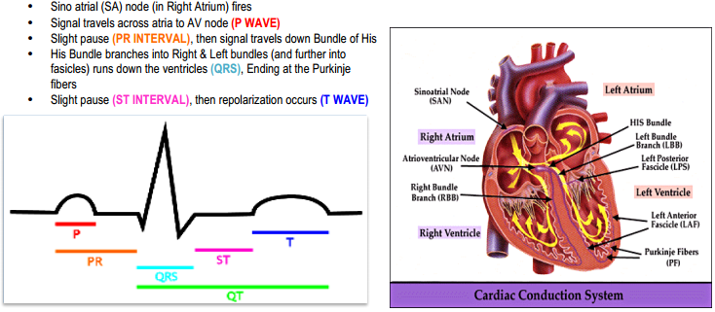
When reading an EKG, it is vital to have a systematic approach!
- Determine Cardiac Rhythm
  - Is the rhythm regular or irregular?
  - Identify atrial activity
  - Determine P-QRS relationship
- Measure heart rate
  - Is the rate normal? (60-100 bpm) bradycardia (<60bpm)? Or tachycardia (>100 bpm)?
How to determine heart rate: count the number of small squares (0.04 secs) between two QRS complexes
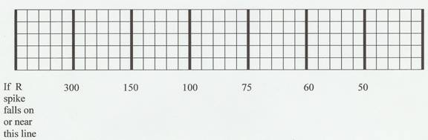
5 small boxes between the 2 QRS complexes | 300 bpm
10 small boxes | 150 bpm
15 small boxes | 100 bpm
20 small boxes | 75 bpm
25 small boxes | 60 bpm
30 small boxes | 50 bpm
35 small boxes | 43 bpm
40 small boxes | 37 bpm

- Evaluate P wave morphology
  - Inspect P waves in lead II and VI for right and left atrial enlargement
    - What is the amplitude? Duration? Direction?
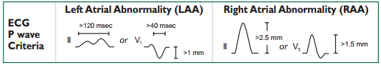
- Assess PR, QRS, and QT interval
  - PR interval- normal is 0.12-0.20 seconds. Is it short or prolonged?
    - Short PR intervals (less than 0.12 second) indicate that the impulse originated somewhere other than the SA node. This variation is associated with junctional arrhythmias and preexcitation syndromes.
    - Prolonged PR intervals (greater than 0.20 second) may represent a conduction delay through the atria or AV junction due to digitalis toxicity or heart block – slowing related to ischemia or conduction tissue disease.
  - QRS interval- normal is (less than or equal to 0.10 seconds.
    - Make sure to check for a bundle branch block!
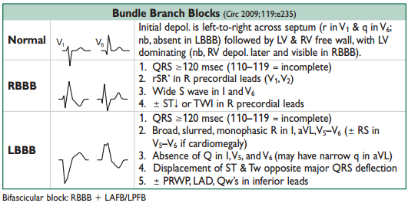
  - QT interval- what is the duration? Normal QT is less than or equal to one-half of the R-R interval (if HR is normal)
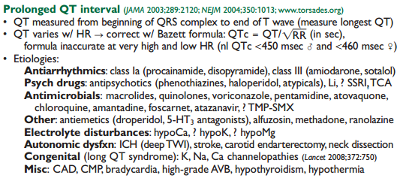
- Determine Mean QRS Axis
  - Normal is between +90 degrees and -30 degrees
  - Is there left or right axis deviation?
    - Check leads I and aVF!
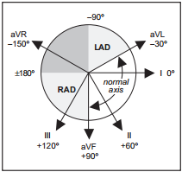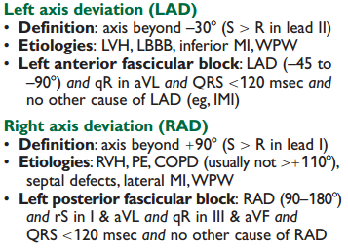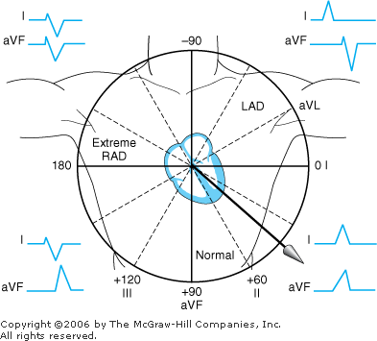
- Evaluate QRS Complex, ST and T wave Morphologies
  - Is a Q wave present? If it is, what is the distribution?
    - Q waves are normal at a width of <0.04 seconds and height of <1/3 of the QRS complex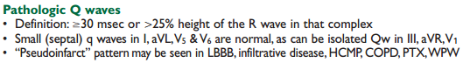
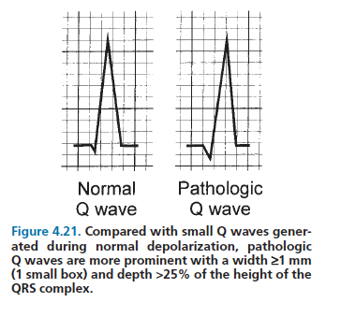
  - Is the QRS amplitude normal? Increased? Or decreased?
    - Check for left or right ventricular hypertrophy!
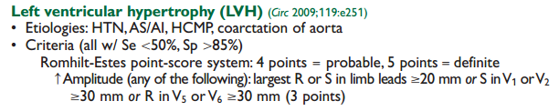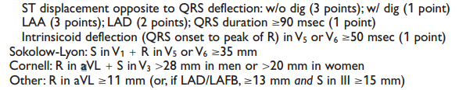
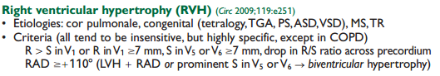
  - Is the ST segment elevated, depressed, or isoelectric?
    - Check for ischemia, infarction, pericarditis, metabolic/chemical abnormalities!
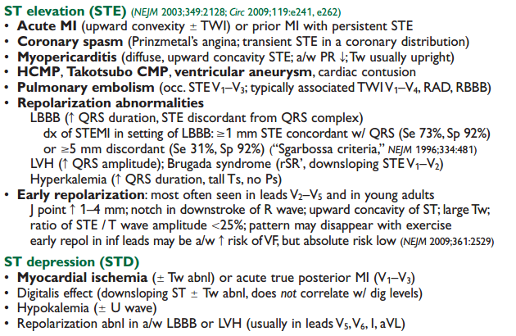
  - Is the T wave upright or inverted?
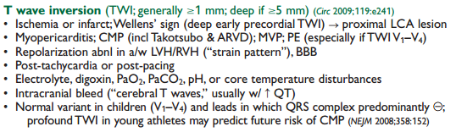
  - Is the amplitude increased or diminished?

- Identify Abnormal ECG Pattern
  - Myocardial ischemia and infarction
  - Cardiac chamber enlargement and hypertrophy
  - Arrhythmias and conduction disturbances
  - Miscellaneous patterns (e.g., pericarditis, WPW syndrome, electrolyte imbalances, drug effects)
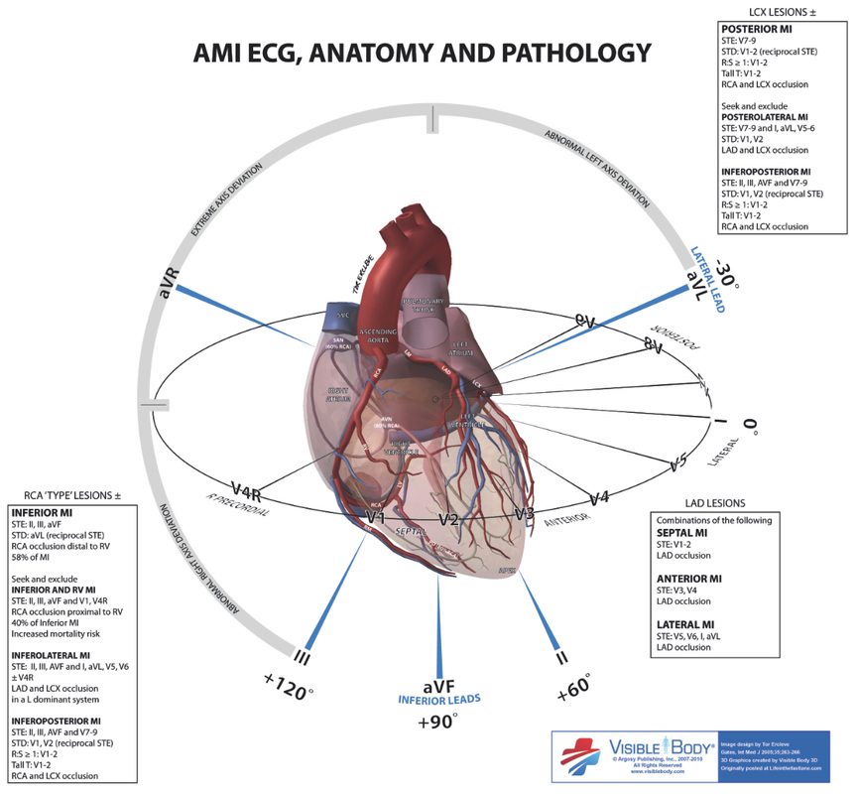
References:
Pocket Medicine: The Massachusetts General Hospital Handbook of Internal Medicine
Clinical Cardiology Made Ridiculously Simple (Edition 4)
Rutgers PANCE/PANRE Review Course
http://www.medskills.eu/index.php/wiki/en/cellular/chest%20pain/heart%20and%20blood%20vessels/ecg%20presentation/
http://www.teaems.com/ekg-review.htm
Fitsweb.uchu.edu
l

